**Manuscript Number** EID-20-1099

**Article Summary Line:** Social distancing is likely to have assisted in mitigating the spread of COVID-19 in South Korea.

**Running Title:** Social distancing and COVID-19, South Korea

**Keywords:** coronavirus disease, COVID-19, SARS-CoV-2, South Korea, social distancing

**Title:** Potential roles of social distancing in mitigating the spread of coronavirus disease 2019 (COVID-19) in South Korea

**Authors:** Sang Woo Park,Kaiyuan Sun,Cécile Viboud,Bryan T. Grenfell,Jonathan Dushoff

**Affiliations:**

Princeton University, Princeton, New Jersey, USA (SW. Park, BT. Grenfell)

National Institutes of Health, Bethesda, Maryland, USA (K. Sun, C. Viboud, BT. Grenfell)

McMaster University, Hamilton, Ontario, Canada (J. Dushoff)

**Funding statement:** JD was supported from the Canadian Institutes of Health Research. The funders had no role in study design, data collection and analysis, decision to publish, or preparation of the manuscript.

**Conflicts of interest:** None

**Abstract — 50 words (limit: 50 words)**

The COVID-19 outbreak in South Korea reached its peak by the end of February but subsided in mid-March. We report here on the likely roles of social distancing in reducing transmission in South Korea. As of March 16, 2020, our analysis predicted that transmission may still persist in some regions.

**Text — 1195 words (limit: 1200 words)**

The first COVID-19 case in South Korea was confirmed on January 20, 2020 (*1*). The disease spread rapidly within a church community in the city of Daegu after the city’s first case was reported on February 18, 2020 (*1*). The chains of transmission that began from this cluster distinguish the epidemic in South Korea from that in any other countries: As of March 16, 2020, 8,236 cases were confirmed, of which 61% were related to the church (*1*).

Several measures were implemented to prevent the spread of COVID-19. On February 20, the Daegu Metropolitan City Government recommended refraining from going outside and wearing masks in everyday life (*2*). On February 23, the national alert level was raised to the highest level (*1*) and the beginning of school semesters were delayed (*3*). Intensive testing and contact tracing efforts further allowed rapid identification and isolation cases and reduction of onward transmission (*4*). Here, we describe potential roles of social distancing in mitigating the spread of COVID-19 in South Korea by using metro traffic data to compare epidemics in two major cities.

**The Study**

We analyzed epidemiological data describing the COVID-19 outbreak in South Korea between January 20–March 16, 2020. Daily number of reported cases in each municipality was transcribed from press releases by the Korea Centers for Disease Control and Prevention (KCDC) (*2*). Partial line lists were transcribed from press releases by the KCDC and municipal governments. All data and code are stored in a publicly available GitHub repository: <https://github.com/parksw3/Korea-analysis>.

We compared epidemiological dynamics of COVID-19 from two major cities: Daegu and Seoul. Between January 20– March 16, 2020, 6,083 and 248 cases from Daegu and Seoul were reported by the KCDC. The epidemic in Daegu is characterized by a single, large peak followed by a decrease (Fig. 1A), whereas the epidemic in Seoul consists of several small outbreaks (Fig. 1B).

Daily number of individuals who boarded the subway or monorail in Daegu and Seoul between 2017–2020 was obtained from data.go.kr and data.seoul.go.kr, respectively (using Seoul lines 1–9, and Daegu lines 1–3; Fig. 1). Soon after the first church-related case was reported, the traffic volume decreased by about 80% and 50% in Daegu and Seoul, respectively.

We reconstructed the time series of incidence proxy , representing the number of infected individuals at time who eventually reported their infection, and estimated the instantaneous reproduction number, , which is defined as the average number of secondary cases caused by an average individual, given conditions at time *t* (*5*). We first adjusted the daily number of reported cases to account for changes in testing criteria (Appendix). Then, we sampled infection dates using inferred onset-to-confirmation delay distributions from the partial line list (Appendix Figure 1) and previously estimated incubation period distribution (Table 1). The time series of number of infected individuals on day , adjusted by testing criteria and right-censoring bias, corresponds to incidence proxy, . Finally, we estimated using the renewal equation (*6*):

where is the generation-interval distribution randomly drawn from a prior distribution (Table 1). We weighted each sample of using a gamma probability distribution with a mean of 2.6 and a standard deviation of 2 to reflect prior knowledge (*6*) and took weighted quantiles to calculate the medians and associated 95% credible intervals. We estimated between February 2, 2020 (14 days after the first confirmed case) and March 10, 2020 (after this point the effects of censoring are too strong for reliable estimates). Implementation details are provided in the Appendix. All analyses were performed using R version 3.6.1 (<https://www.r-project.org/>).

Fig. 2 compares the reconstructed incidence proxy (A,B) and estimates of (C,D) in Daegu and Seoul. In Daegu, incidence peaked shortly after the first case was confirmed and then decreased (Fig. 2A). The first confirmed case in Daegu had developed symptoms on February 7, 2020, and visited the church on February 9 and 16, 2020, indicating the disease was likely spreading within the church community earlier (*1*). Likewise, the estimates of gradually decrease and eventually drop below 1 about a week after the reporting of its first case, coinciding with the decrease in the metro traffic volume (Fig. 2C). The initial decrease in is likely to be caused by our resampling method for infection times for each reported case, which over-smoothes the incidence curve and estimates (*7*). In Seoul, estimates of decrease slightly but remain around 1 (Fig. 2D), which may be explained by less intense social distancing. Stronger distancing or further intervention would have been necessary to reduce below 1.

While we found clear, positive correlations between the normalized traffic and the median estimates of in both Daegu (*r* = 0*.*93; 95% CI: 0.86–0.96; Appendix Figure 2) and Seoul (*r* = 0*.*76; 95% CI: 0.60–0.87; Appendix Figure 2), these correlations are conflated by time trends, and by other measures that could have affected . We did not find clear signatures of lagged correlation between and traffic volume (Appendix Figure 3). Similar patterns in were found in directly surrounding provinces (Gyeongsangbuk-do and Gyeonggi-do), demonstrating robustness of our analysis (Appendix Figure 4).

**Conclusions**

The South Korean experience with COVID-19 provides evidence that epidemics can be suppressed with less extreme measures than those taken by China (8). It demonstrates the necessity of prompt identification and isolation of cases in preventing spread (*4*). Our analysis reveals potential roles of social distancing in assisting such efforts. Even though social distancing alone may not prevent the spread, it can flatten the epidemic curve (cf. Fig. 2B,D) and reduce burden for healthcare system (*9*).

Our study is not without limitations. We did not account for differences in the delay distributions or changes in the number of tests among cities. We did not have sufficient data to account for these factors. Nonetheless, the robustness of our findings is supported by the sensitivity analyses (Appendix Fig. 5-8). We were also unable to distinguish local and imported cases, which may overestimate (*10*). We were able to perform a separate analysis for Seoul that accounts for imported cases using line list provided by the Seoul Metropolitan Government; our qualitative conclusions remained robust (Appendix Figure 9). Finally, the method of resampling infection time over-smoothes estimates, but still captures qualitatively changes in (*7*).

We used metro traffic to quantify the degree of social distancing. The 80% decrease in traffic volume suggests that distancing measures in Daegu may be comparable to that in Wuhan, China (*11*). We were not able to directly estimate the effect of social distancing on epidemiological dynamics. Other measures, such as intensive testing of core transmission groups and school closure, are also likely to have affected dynamics. Future studies should consider quantifying contributions of different measures in preventing the spread.

Our study highlights the importance of considering geographical heterogeneity in estimating epidemic potential. The decrease in the number of reported cases in South Korea was driven by the sharp decrease in Daegu. Our analysis revealed that the epidemic could have still persisted in other regions, including Seoul and Gyeonggi-do. Relatively weak distancing may have assisted the recent resurgence of COVID-19 cases in Seoul (*1*).

**Disclaimers**

This article does not necessarily represent the views of the NIH or the US government.

**Author Bio**

Sang Woo Park is a Ph.D. student in the Ecology and Evolutionary Biology department at Princeton University. His research focuses on mathematical and statistical modeling of infectious diseases.

**References**

1. Korea Centers for Disease Control and Prevention (KCDC). Press release [in Korean]. [cited 2020 Jan 20 – Jul 23]. <https://www.cdc.go.kr/board/board.es?mid=a20501000000&bid=0015#>
2. Daegu Metropolitan City Government. Press Release [in Korean] [cited 2020 Jul 22]. <http://152.99.22.79:8080/SynapDocViewServer/viewer/doc.html?key=2c948aed7356835e017378b583741d07&contextPath=/SynapDocViewServer/>
3. Korean Ministry of Education. Press Release [in Korean] [cited 2020 Jul 22]. <https://www.moe.go.kr/boardCnts/view.do?boardID=294&boardSeq=79829&lev=0&searchType=null&statusYN=W&page=21&s=moe&m=020402&opType=N>
4. Park YJ, Choe YJ, Park SY, Kim YM, Kim J, Kweon S, et al. Contact tracing during Coronavirus Disease Outbreak, South Korea, 2020. Emerg Inf Dis. 2020. <https://doi.org/10.3201/eid2610.201315>
5. Fraser C. Estimating individual and household reproduction numbers in an emerging epidemic. PLoS one. 2007; 2(8). <https://doi.org/10.1371/journal.pone.0000758>
6. Abbott S, Hellewell J, Thompson RN, Sherratt K, Gibbs HP, Bosse NI, et al. Estimating the time-varying reproduction number of SARS-CoV-2 using national and subnational case counts [version 1; peer review: awaiting peer review]. Wellcome Open Res. 2020; 5(112). <https://doi.org/10.12688/wellcomeopenres.16006.1>
7. Gostic KM, McGough L, Baskerville E, Abbott S, Joshi K, Tedijanto C, et al. Practical considerations for measuring the effective reproductive number, [cited 2020 Jul 22]. <https://www.medrxiv.org/content/10.1101/2020.06.18.20134858v2>
8. Kickbusch I and Leung G. Response to the emerging novel coronavirus outbreak. BMJ. 2020; 368:m406 https://doi.org/10.1136/bmj.m406
9. Anderson RM, Heesterbeek H, Klinkenberg D, and Hollingsworth TD. How will country-based mitigation measures influence the course of the COVID-19 epidemic? Lancet. 2020; 395(10228):931-934. https://doi.org/10.1016/S0140-6736(20)30567-5
10. Thompson RN, Stockwin JE, van Gaalen RD, Polonsky JA, Kamvar ZN, Demarsh PA, et al. Improved inference of time-varying reproduction numbers during infectious disease outbreaks. Epidemics. 2019; 29:100356. https://doi.org/10.1016/j.epidem.2019.100356
11. Kraemer MU, Yang C-H, Gutierrez B, Wu C-H, Klein B, Pigott DM, et al. The effect of human mobility and control measures on the COVID-19 epidemic in China. Science. 2020; 368(6490). <https://doi.org/10.1126/science.abb4218>
12. Backer JA, Klinkenberg D, and Wallinga J. Incubation period of 2019 novel coronavirus (2019-nCoV) infections among travellers from Wuhan, China, 20–28 January 2020. Euro Surveill. 2020; 25(5). https://doi.org/10.2807/1560-7917.ES.2020.25.5.2000062
13. Ferretti L, Wymant C, Kendall M, Zhao L, Nurtay A, Abeler-Dörner L, et. Quantifying dynamics of SARS-CoV-2 transmission suggests epidemic controll with digital contact tracing. Science. 2020; 368(6491). <https://doi.org/10.1126/science.abb6936>
14. Ganyani T, Kremer C, Chen D, Torneri A, Faes C, Wallinga J, et al. Estimating the generation interval for coronavirus disease (COVID-19) based on symptom onset, March 2020. Euro Surrveill. 2020; 25(17). <https://doi.org/10.2807/1560-7917.ES.2020.25.17.2000257>

Address for correspondence: Sang Woo Park, Department of Ecology and Evolutionary Biology, 106A Guyot Hall, Princeton University, Princeton, NJ 08544-2016, USA; email: swp2@princeton.edu

**Table 1.** Assumed incubation and generation-interval distributions.

|  |  |  |  |
| --- | --- | --- | --- |
|  | Parameterization | Priors | Source |
| Incubation period distribution | Gamma(*µI, µ*2*I/σ*2) | *µI* ∼ Gamma(6*.*5 days*,* 145)  *σ* ∼ Gamma(2*.*6*,* 25) | (*12*) |
| Generation-interval distribution | NegativeBinomial(*µG, θ*) | *µG* ∼ Gamma(5 days*,* 62)  *θ* ∼ Gamma(5*,* 20) | (*13,14*) |

*Table footnotes: Gamma distributions are parameterized using its mean and shape. Negative binomial distributions are parameterized using its mean and dispersion. Priors are chosen such that the 95% quantiles of prior means and standard deviations are consistent with previous estimates.

**Figure 1A:**

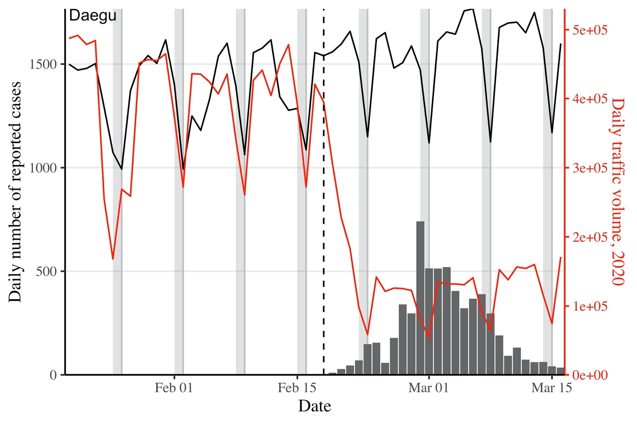

**Figure 1B:**

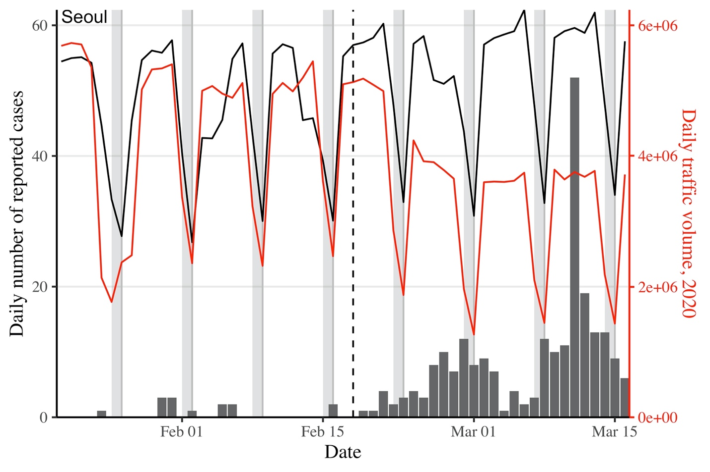

**Figure 1.** Comparison of epidemiological and traffic data from Daegu (A) and Seoul (B). Solid lines represent the daily metro traffic volume in 2020 (red) and mean daily metro traffic volume between 2017–2019 (black). Daily traffic from previous years have been shifted by 1–3 days to align day of the weeks. Vertical, dashed lines indicate Feb 18, 2020, when the first case was confirmed in Daegu. Gray bars indicate weekends.

**Figure 2A:**

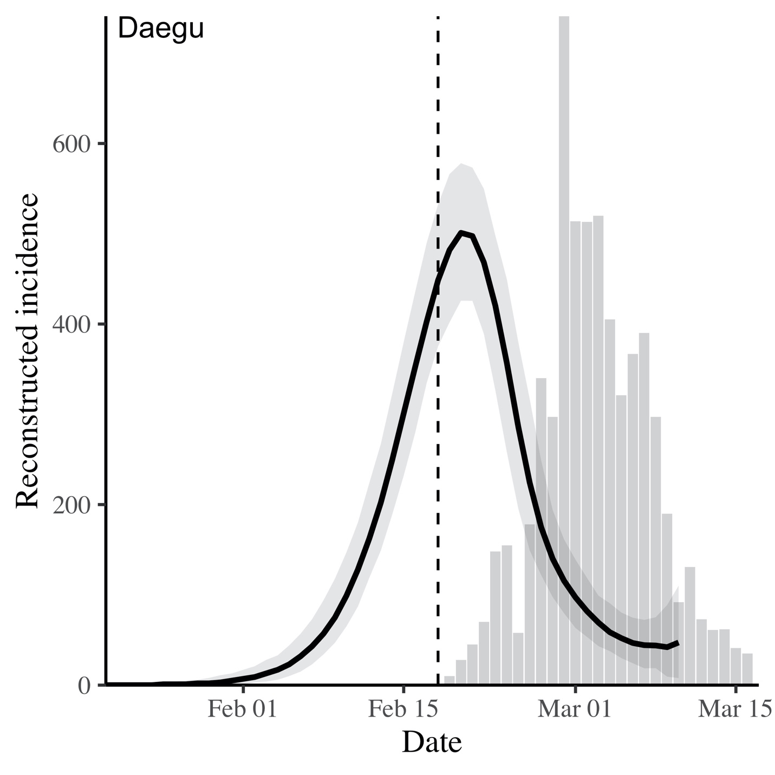

**Figure 2B:**

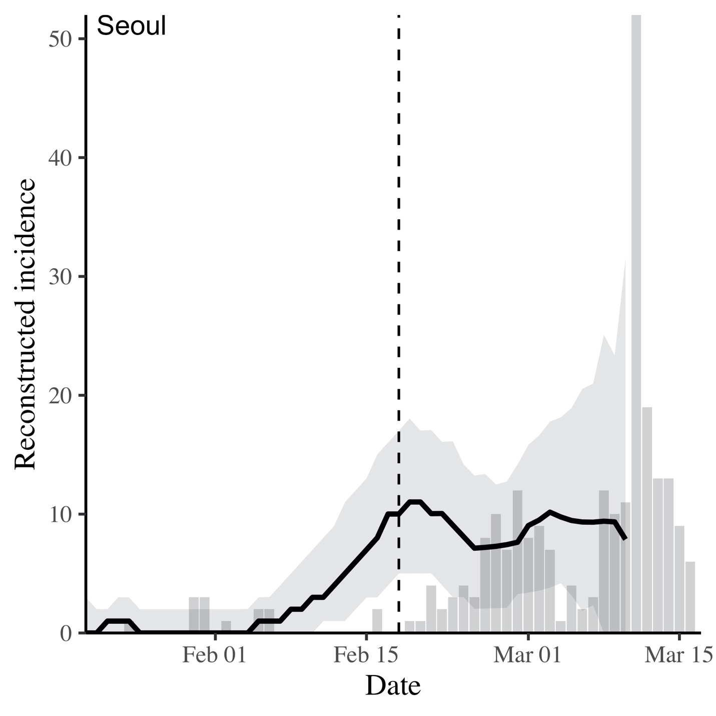

**Figure 2C:**

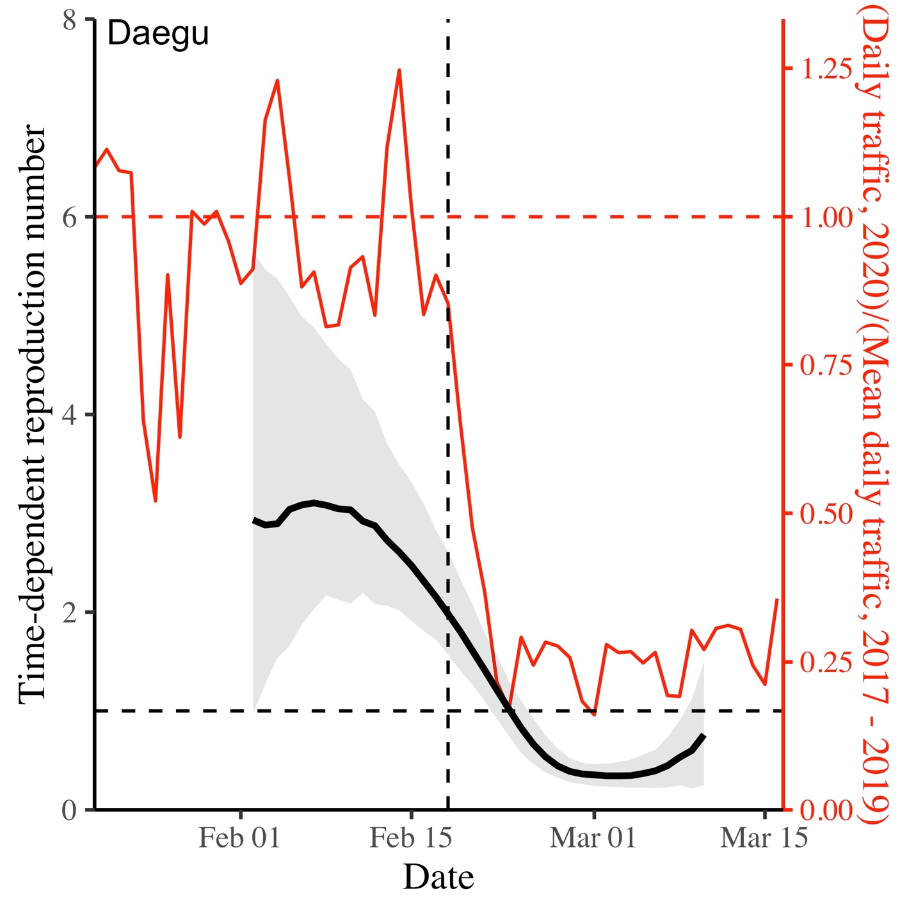

**Figure 2D:**

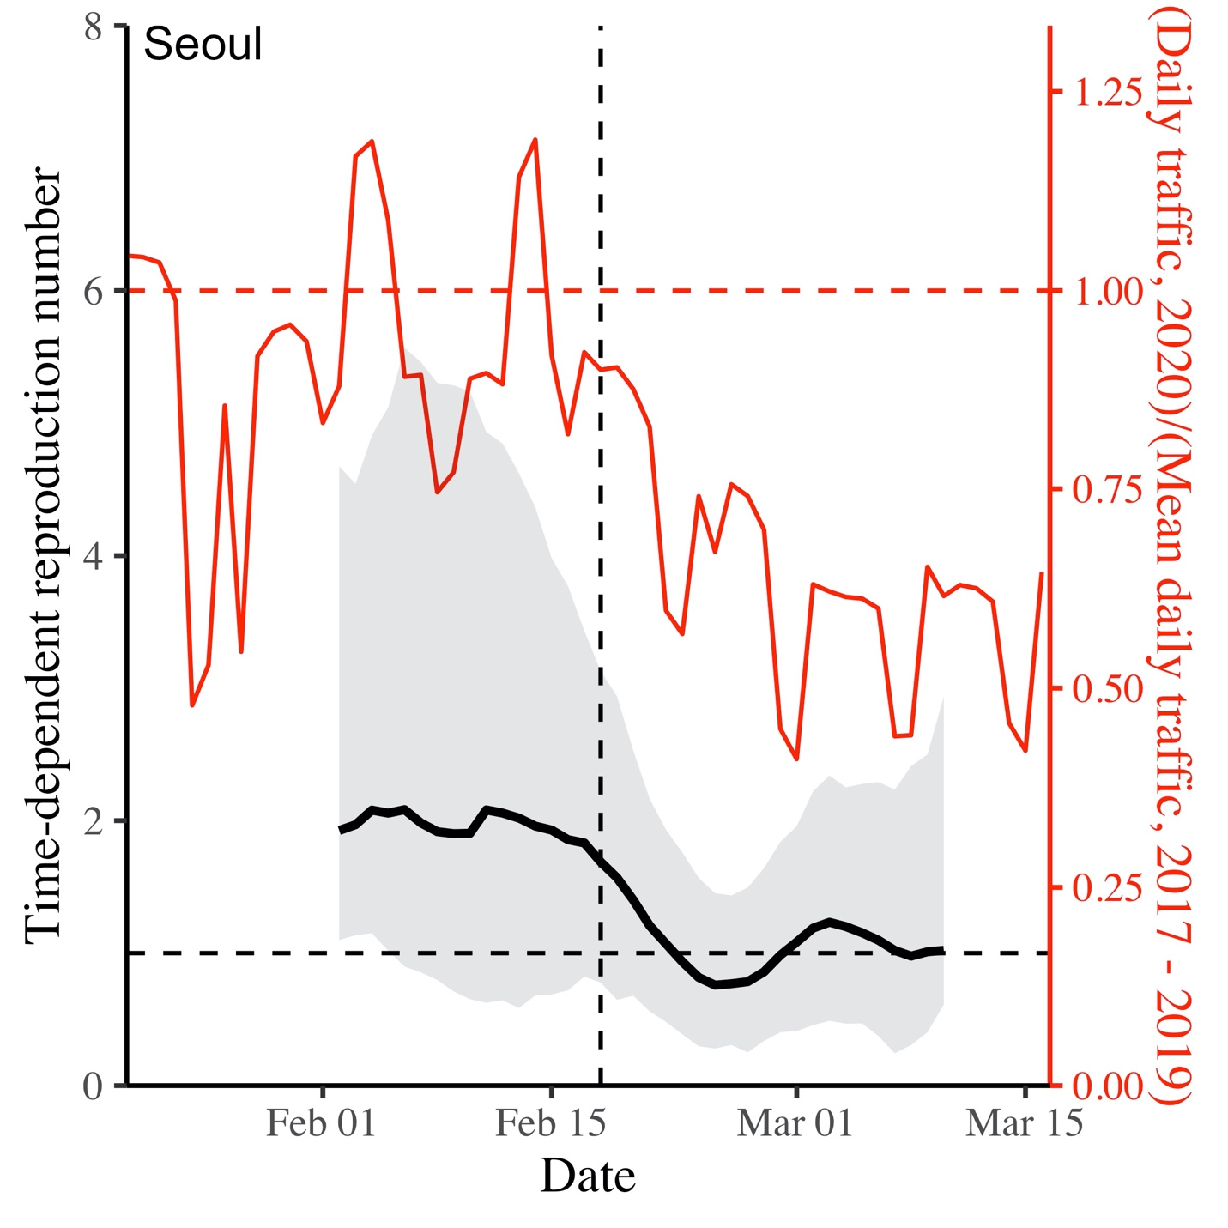

**Figure 2.** Comparison of reconstructed incidence proxy and instantaneous reproduction number in Daegu (A,C) and Seoul (B,D). The instantaneous reproduction number reflects transmission dynamics at time .Black lines and gray ribbons represent the median estimates of reconstructed incidence (A,B) and (C,D) and their corresponding 95% credible intervals. Bar plots show the number of reported cases. Red lines represent the normalized traffic volume. Vertical lines indicate Feb 18, 2020, when the first case was confirmed in Daegu.